Data Analysis and Model Finalization
Overview of the dataset
The predictive modeling framework developed in this work relies on multi-year pollutant measurements obtained from the Central Pollution Control Board (CPCB) Continuous Ambient Air Quality Monitoring Stations (CAAQMS).
For this study, daily averaged pollutant measurements were collected from a single monitoring site covering a five-year period from January 2020 through December 2024. The dataset consists of 1827 daily observations and includes measurements of ten key pollutants commonly associated with urban atmospheric chemistry. The monitored variables include particulate matter (PM₂.₅ and PM₁₀), nitrogen oxides (NO, NO₂, and NOx), ammonia (NH₃), sulfur dioxide (SO₂), carbon monoxide (CO), ozone (O₃), and benzene as a proxy indicator for volatile organic compounds (VOCs).
These pollutants represent the primary chemical species involved in tropospheric ozone formation and urban pollution cycles. Ozone is a secondary pollutant that forms through photochemical reactions involving nitrogen oxides and volatile organic compounds under the influence of solar radiation. Consequently, understanding the statistical behavior and interrelationships among these precursor species is essential before constructing predictive models.
 | PM2.5 (µg/m³) | PM10 (µg/m³) | NO (µg/m³) | NO2 (µg/m³) | NOx (ppb) | NH3 (µg/m³) | SO2 (µg/m³) | CO (mg/m³) | Ozone (µg/m³) | Benzene (µg/m³)
count | 1827.000000 | 1827.000000 | 1827.000000 | 1827.000000 | 1827.000000 | 1827.000000 | 1827.000000 | 1827.000000 | 1827.000000 | 1827.000000
mean | 109.060879 | 166.656952 | 37.531545 | 53.063876 | 58.915533 | 40.960470 | 14.423263 | 1.775033 | 24.817967 | 6.876305
std | 84.649643 | 104.287585 | 32.715482 | 47.982101 | 46.150381 | 40.046335 | 9.800174 | 1.148245 | 14.688249 | 7.521187
min | 10.020000 | 11.480000 | 3.690000 | 2.296667 | 7.340000 | 1.990000 | 1.120000 | 0.100000 | 0.890000 | 0.000000
25% | 48.280000 | 83.600000 | 16.745000 | 23.200000 | 30.445000 | 20.712024 | 8.420000 | 0.985729 | 14.169271 | 2.164253
50% | 82.480000 | 146.220000 | 28.750000 | 35.990000 | 45.140000 | 31.250000 | 12.060000 | 1.450000 | 21.411458 | 4.453264
75% | 143.907292 | 224.150000 | 44.210938 | 62.449236 | 68.670000 | 43.000000 | 17.030000 | 2.264062 | 32.596354 | 9.677465
max | 659.290000 | 691.840000 | 314.907051 | 322.857246 | 323.138333 | 349.080000 | 111.030000 | 10.320000 | 102.160000 | 103.750000
STATISTICS TABLE = TABLE X
Table X summarizes the statistical characteristics of the dataset, including mean values, standard deviations, quartiles, and extreme values for each pollutant. The results show substantial variability across pollutants, with particulate matter and nitrogen oxides exhibiting particularly large ranges.
The dataset indicates a mean PM₂.₅ concentration of approximately 109 µg/m³ and a mean PM₁₀ concentration of approximately 166 µg/m³. These values reflect the severe particulate pollution levels commonly observed in large metropolitan regions. Maximum PM₁₀ concentrations exceeding 690 µg/m³ were observed, indicating episodic extreme pollution events likely associated with dust storms, biomass burning, or seasonal atmospheric stagnation.
Nitrogen oxide concentrations also show substantial variability, with NO₂ reaching maximum values above 320 µg/m³ and NOx exceeding 320 ppb in certain cases. These elevated levels are consistent with traffic-dominated urban environments where vehicular emissions represent the dominant source of nitrogen oxides.
Ozone concentrations display a comparatively narrower distribution, with a mean concentration of approximately 24.8 µg/m³ and a maximum value slightly above 100 µg/m³. This reflects the secondary nature of ozone formation, which depends not only on precursor emissions but also on meteorological conditions and photochemical processes.
Benzene concentrations, representing a proxy for volatile organic compounds, exhibit a highly skewed distribution with relatively low baseline values but occasional spikes exceeding 100 µg/m³. These episodic increases likely correspond to localized emission sources such as fuel evaporation, industrial activities, or incomplete combustion.
Overall, the dataset provides a sufficiently large and diverse set of observations to investigate the complex interactions between atmospheric pollutants and to train machine learning models capable of capturing nonlinear pollution dynamics.

Data Preprocessing and Cleaning
Before performing any statistical analysis or machine learning modeling, extensive preprocessing was required to ensure that the dataset was consistent, continuous, and suitable for time-series analysis.
The raw CPCB data were originally provided as separate yearly CSV files containing daily pollutant measurements. These individual datasets were first merged into a single unified dataframe spanning the entire five-year observation period. During this merging process, column names were standardized to remove formatting inconsistencies such as trailing whitespace or inconsistent capitalization.
The timestamp column was then converted from string format to a proper datetime object using Python’s datetime parsing utilities. Establishing a correct datetime index is essential for time-series analysis, as it allows chronological sorting, temporal interpolation, and the calculation of lag features.
After timestamp conversion, the dataset was sorted chronologically and reindexed to ensure a continuous daily time series. This step guarantees that each row corresponds to a unique observation date and enables subsequent time-based operations such as rolling averages and temporal interpolation.
A significant challenge encountered during preprocessing was the presence of missing values. These gaps arose primarily due to sensor maintenance periods, communication failures, or temporary calibration events at the monitoring station. Missing data can significantly degrade model performance if not handled appropriately, as most machine learning algorithms require complete numerical inputs.
To address this issue, a multi-stage missing value imputation strategy was adopted. The primary method used was time-based linear interpolation, which estimates missing values based on the surrounding observations. If the pollutant concentration at times (t_1) and (t_2) are known while the value at time (t) is missing, the interpolated value is estimated using the linear interpolation formula:
[
y(t) = y(t_1) + \frac{t - t_1}{t_2 - t_1}\left[y(t_2) - y(t_1)\right]
]
This approach assumes that pollutant concentrations evolve smoothly over short time intervals, which is a reasonable approximation given that atmospheric transport and chemical reactions typically produce gradual concentration changes rather than abrupt discontinuities.
After interpolation, any remaining missing values occurring at the boundaries of the dataset were handled using forward and backward filling methods. Forward filling replaces missing values with the most recent previous observation, while backward filling uses the next available observation. These techniques ensure that the dataset remains fully populated without introducing unrealistic concentration jumps.
Following these cleaning steps, the dataset contained no missing values and was suitable for further statistical analysis.

Distribution Characteristics of Pollutants
Understanding the statistical distribution of pollutant concentrations is a critical step in exploratory data analysis, as it reveals whether the variables follow Gaussian distributions or exhibit heavy-tailed behavior.
Distribution of Pollutant Concentrations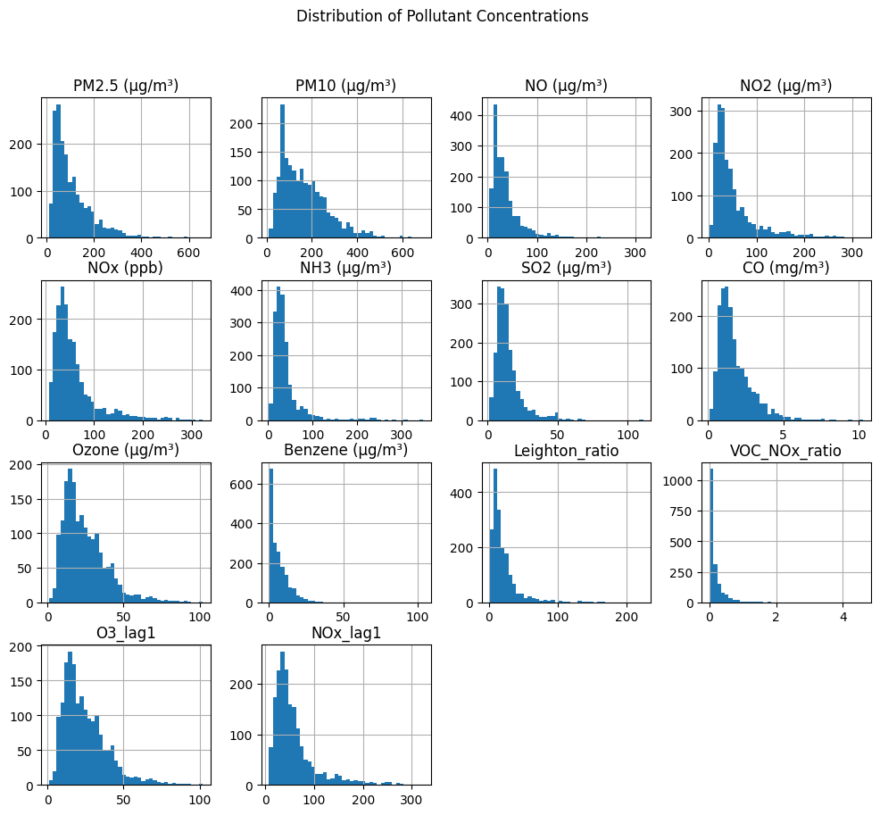
The histograms of pollutant concentrations reveal that most variables exhibit strongly right-skewed distributions. This indicates that while typical pollutant levels remain moderate for most days, occasional extreme pollution episodes produce large outliers.
Particulate matter variables (PM₂.₅ and PM₁₀) show the most pronounced heavy tails. These distributions indicate that rare but severe pollution events significantly influence overall air quality statistics. Such behavior is common in urban environments where meteorological conditions such as winter inversions can trap pollutants near the surface.
Nitrogen oxide species also exhibit skewed distributions, reflecting the highly variable nature of traffic emissions. During peak traffic hours or under stagnant atmospheric conditions, NO and NO₂ concentrations can increase dramatically.
Ozone concentrations, on the other hand, display a more symmetric distribution compared to other pollutants. This suggests that ozone formation is constrained by chemical equilibrium processes and is less prone to extreme spikes than primary pollutants.
These non-Gaussian distributions have important implications for model selection. Traditional linear regression models often assume normally distributed residuals and may perform poorly when applied to skewed datasets with extreme outliers. Therefore, machine learning algorithms capable of capturing nonlinear relationships and handling skewed distributions are preferred.

Photochemical Equilibrium Analysis
A key component of atmospheric ozone chemistry is the photostationary equilibrium between nitrogen oxides and ozone. The fundamental reactions governing this equilibrium are:
[NO_2 + h -> NO + O]
[O + O_2 -> O_3]
[NO + O_3 -> NO_2]
These reactions form a cyclic process known as the NO–NO₂–O₃ photostationary state. Under ideal conditions, the relative concentrations of these species satisfy a balance relationship that can be evaluated using the Leighton ratio.
The Leighton ratio is defined as: = [NO][O_3] / [NO_2]
This ratio provides insight into whether the observed atmospheric chemistry follows the expected equilibrium conditions or whether additional chemical pathways are influencing ozone formation.
Leighton Photostationary Ratio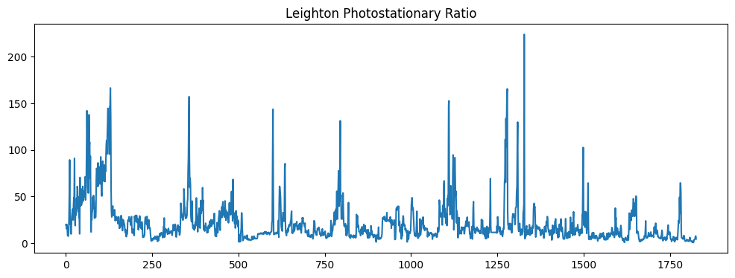
The calculated Leighton ratio in this dataset shows large fluctuations across the observation period, with values ranging from approximately 5 to over 200. Such variability indicates that the atmosphere frequently deviates from simple photochemical equilibrium.
These deviations suggest the presence of additional reaction pathways, most notably those involving volatile organic compounds. VOC oxidation generates peroxy radicals that convert NO into NO₂ without consuming ozone, thereby enhancing ozone production.
The presence of such nonlinear chemical effects confirms that ozone dynamics cannot be captured using simple equilibrium models alone. Instead, predictive models must incorporate both data-driven relationships and physical constraints governing atmospheric chemistry.

VOC–NOx Chemical Regime Diagnostics
Another important diagnostic for ozone formation is the ratio of volatile organic compounds to nitrogen oxides. This ratio determines whether ozone formation is limited by VOC availability or by nitrogen oxide concentrations.
The VOC–NOx ratio is commonly used to classify atmospheric chemical regimes:
VOC/NOx Ratio | Chemical Regime
< 0.1 | VOC-limited
0.1–0.3 | Transitional
> 0.3 | NOx-limited
In this dataset, benzene concentrations were used as a proxy for VOC emissions, while NOx measurements represent nitrogen oxide levels.
VOC–NOx Ratio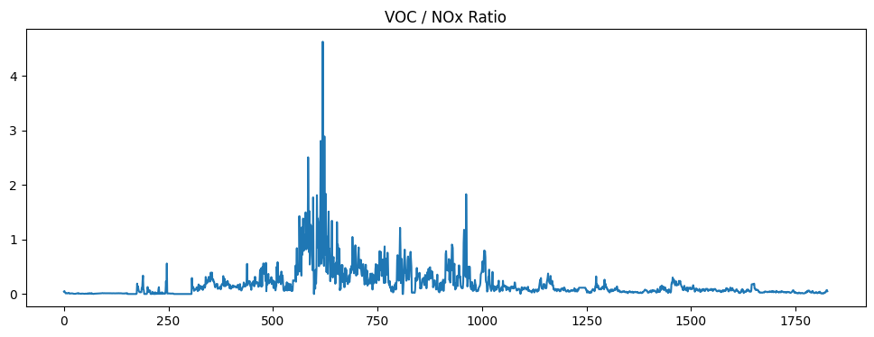
The calculated VOC–NOx ratio indicates that most observations fall within the VOC-limited regime. This finding is consistent with the characteristics of large urban centers where nitrogen oxide emissions from vehicles are abundant while VOC emissions are comparatively lower.
Occasional spikes in the VOC–NOx ratio were observed, indicating episodic VOC emission events. These events likely correspond to industrial activities, solvent use, or fuel evaporation.
The predominance of a VOC-limited regime implies that reducing VOC emissions may be more effective for controlling ozone levels than reducing NOx emissions alone.

4.6 Pollutant–Ozone Relationship Analysis
To further understand the relationships between ozone and its precursor species, pollutant concentrations were plotted as functions of ozone concentration.
PM vs Ozone, NOx vs Ozone, Combustion Pollutants vs Ozone, VOC Proxy vs Ozone
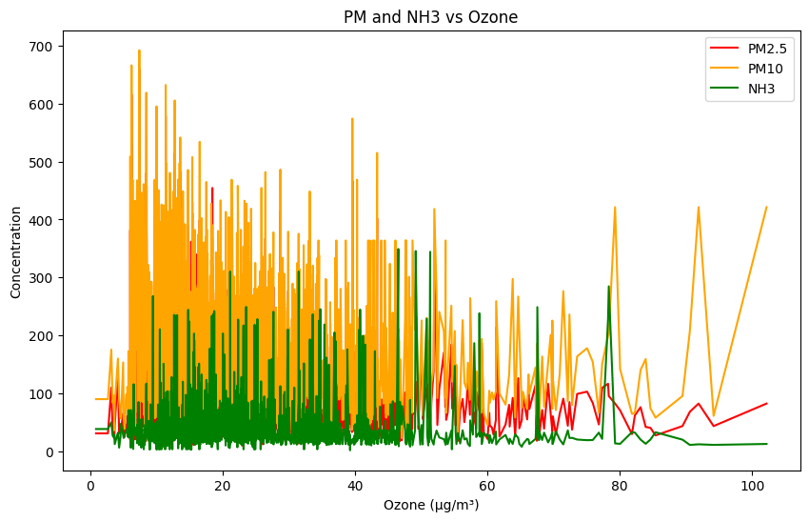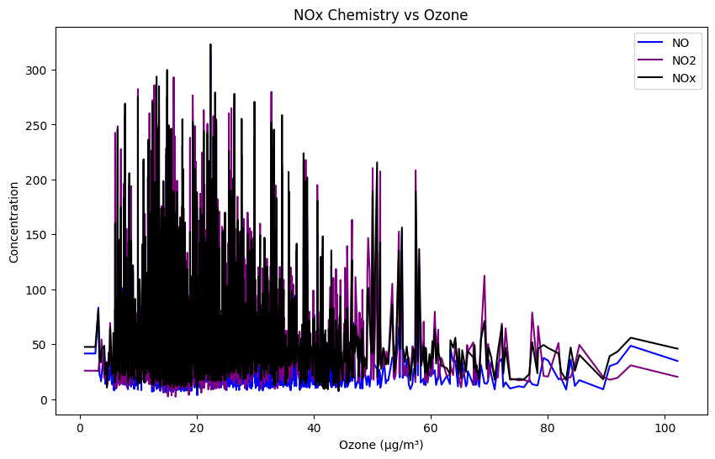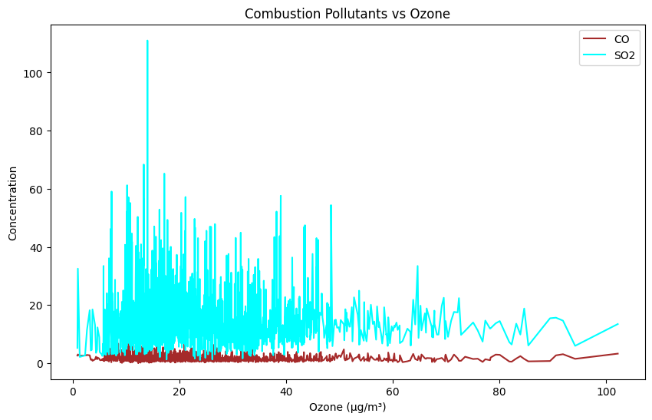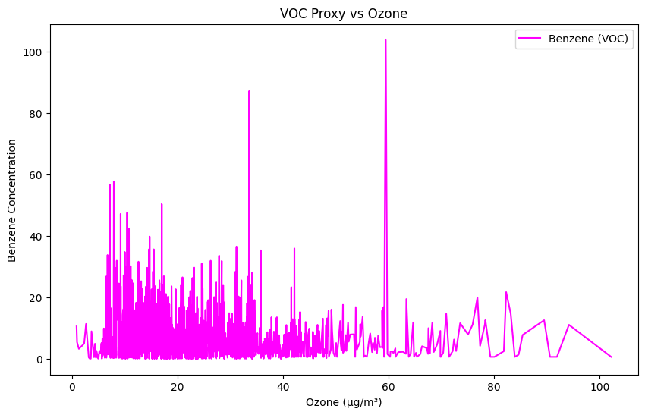
Nitrogen oxides exhibit a clear inverse relationship with ozone concentration. As ozone levels increase, NO and NOx concentrations generally decrease. This pattern reflects the NO titration effect, where nitric oxide reacts with ozone to form nitrogen dioxide.
Particulate matter concentrations show little direct correlation with ozone levels. While particulate pollution and ozone formation may share common emission sources, their chemical formation pathways are largely independent.
Combustion pollutants such as CO display moderate variability but do not exhibit strong direct correlations with ozone concentration.
Benzene, representing VOC emissions, shows episodic increases that occasionally coincide with elevated ozone levels. This behavior supports the role of VOCs in driving photochemical ozone production.
Overall, the pollutant–ozone relationships appear highly nonlinear and exhibit significant variability. These characteristics highlight the need for flexible modeling approaches capable of capturing complex interactions between atmospheric variables.

4.7 Lag Dependence and Temporal Dynamics
Time-series analysis also examined the lagged relationships between ozone and precursor species. A lagged variable representing the previous day’s NOx concentration was introduced to evaluate whether ozone levels depend on earlier emissions.
The correlation between ozone concentration and the previous day’s NOx level was found to be approximately −0.10. This weak correlation indicates that ozone formation cannot be explained solely by simple lag relationships with individual precursor species.
Instead, ozone dynamics are influenced by a combination of chemical reactions, meteorological conditions, and multi-day pollutant accumulation processes.
These findings suggest that models capable of learning long-range temporal dependencies are required to capture the full dynamics of urban air pollution.

4.8 Model Selection Justification
The insights obtained from the exploratory data analysis guided the selection of the modeling framework used in this study.
First, the nonlinear and skewed nature of pollutant distributions indicates that tree-based machine learning models such as XGBoost are well suited for capturing complex relationships between variables. XGBoost can automatically detect nonlinear interactions and piecewise relationships without requiring explicit feature transformations.
Second, the presence of strong temporal patterns in the pollutant time series suggests that recurrent neural networks such as Long Short-Term Memory (LSTM) networks can effectively capture temporal dependencies and seasonal emission cycles.
Finally, the photochemical equilibrium analysis revealed that ozone dynamics are governed by known physical reaction mechanisms. Physics-Informed Neural Networks (PINNs) provide a framework for incorporating these reaction equations directly into the learning process, ensuring that model predictions remain consistent with atmospheric chemistry principles.
By combining these complementary modeling approaches, the proposed hybrid framework aims to leverage both data-driven insights and physical constraints to achieve accurate and physically interpretable ozone predictions.
